HW1: Mid-term assignment report
Tiago da Silva Ribeiro Vaz Oliveira [93456], 2021-05-11

Índice
1 Introduction 2
1.1 Overview of the work 2
1.2 Current limitations 2
2 Product specification 2
2.1 Functional scope and supported interactions 2
2.2 System architecture 3
2.3 API for developers 4
2 5
3 Quality assurance 6
3.1 Overall strategy for testing 6
3.2 Unit and integration testing 6
3.3 Functional testing 8
2.1 8
3.4 Static code analysis 8
3.5 Continuous integration pipeline 10
4 References & resources 11

Introduction

Overview of the work
This report presents the midterm individual project required for TQS, covering both the software product features and the adopted quality assurance strategy.
The product consists in a website where the user can access to consult the air pollution of a
certain place as well as its coordinates. He can consult the data about today, about the next five days and about the last five days (including the “today”). In the data provided we will be presented with a table with several parameters such as coordinates the date of the day and the amount of each pollutant for that day.

Current limitations
The biggest limitation in the interface it is that it is a bit poor without very much style and color in it. Besides that, an indicator in the tables of the air pollution data, about if that amount of pollutant is bad or not for the people’s health like a red flag if it is bad and a green one If it is not.
Another limitation is that one of the APIs used in this product is not 100% open source and once the demo is over it is needed to start paying it or create a new account and generate a new API key to keep receiving the data in the website. Another limitation is that the product is not deployed, so it can only be accessed locally.
- 2 Product specification

Functional scope and supported interactions
The user will interact with the system by simply accessing its website ( in this case it is not deployed so it can only be accessed locally).
This products main page interface is simply a search bar and a drop down. The search bar is where the user inputs the city of which he wants to consult the air pollution and the drop down has three different options which are three different end points the user can access to consult different data. He can access the air pollution for today with the option “Now”, he can access the air pollution for the next five days with the option “Next” and finally the air pollution for the last five days (including today) with the option “Forecast”.

Scenario 1:
Accessing the air pollution about today for the location “Aveiro”.

Scenario 2:
Accessing the air pollution about the next five days for the location “Aveiro”.

Scenario 3:
Accessing the air pollution about the last five days (including today) for the location “Aveiro”.

System architecture
The project was made around spring boot. I have a controller that represents the API and a service that is used by the controller to access the external API. I used two different external APIs, the first one gives me the coordinates of a determined place by having its name and the second one gives me the air pollution for today, forecast and last days for a specific location. For those cases where the user asks for the same information several times in a short time I implemented a cache that stores the data that was requested for a determined time (to be specified in the constructor). For the frontend it was used Thymeleaf to link the frontend with the backend (the html pages with the rest controller).

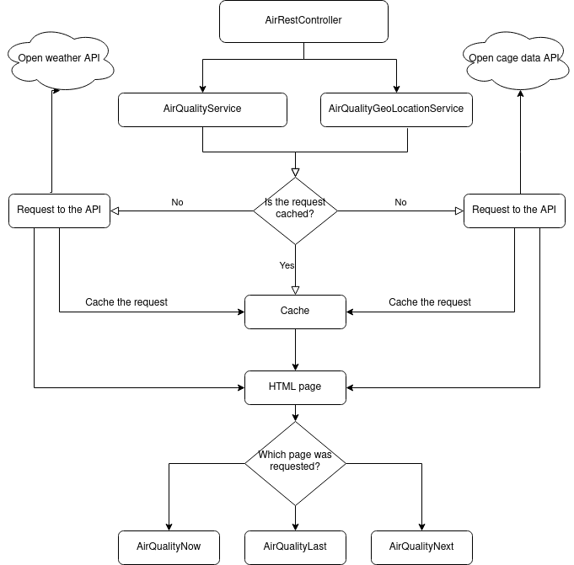

Fig. 1 - Architecture diagram

API for developers
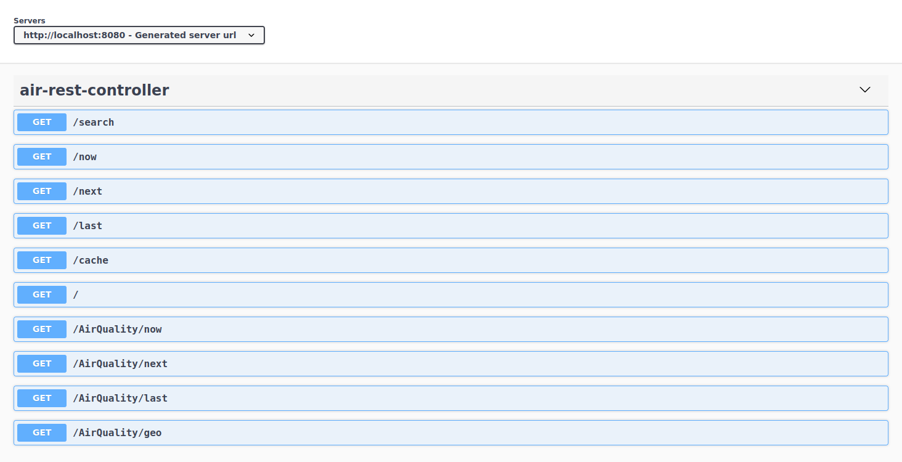
Fig. 2 – Product API documentation

/search:

This endpoint leads the user to the search page where he can choose the service he wants and the location.

/now:

This endpoint leads the user to the air pollution data about today for a location he inputed.

/next:

This endpoint leads the user to the air pollution data about the next five days for a location he inputed.

/last:

This endpoint leads the user to the air pollution data about the last five days for a location he inputed.

/cache:

This endpoint leads a developer to the information cached in that moment in xml or json format.

/:

This endpoint is the root.

/Airquality/now:

This endpoint leads a developer to the air pollution data about today for a location but in xml or json format.

/Airquality/next:

This endpoint leads a developer to the air pollution data about the next five days for a location but in xlm or json format.

/AirQuality/last:

This endpoint leads a developer to the air pollution data about the last five days for a location but in xlm or json format.

/AirQuality/geo:

This endpoint leads a developer to the coordinates for a location in xml or json format.

Quality assurance

Overall strategy for testing
The test development stategy was TDD some code had to be changed with the development of the tests.
For the external API I used rest-assured, for the controller Mockmvc and for the interface selenium.
To test the cache I developed unit tests.

Unit and integration testing

The cache implementation was tested with unit tests, testing every function in a test as well as the time to live policy that it implements.

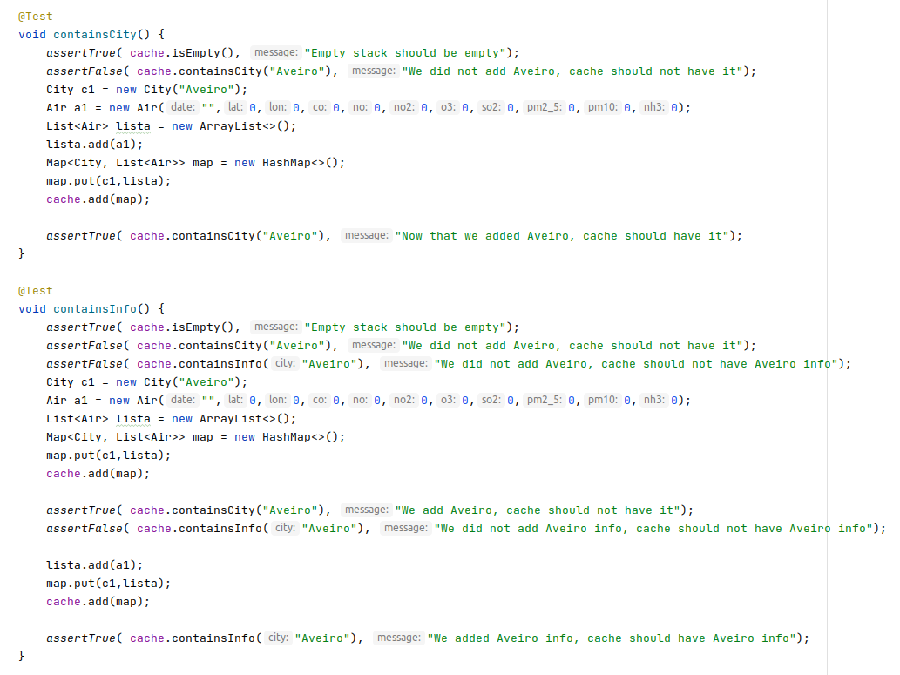

Fig. 3 – Example of cache unit tests

The external API was tested with rest assured.

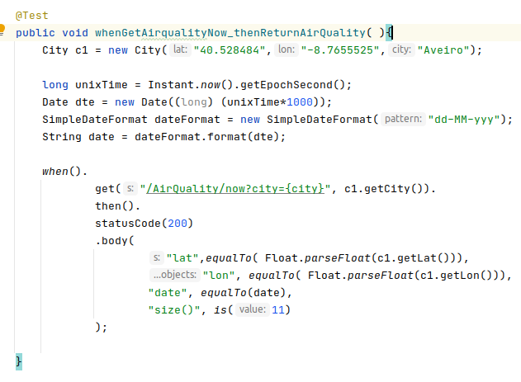

Fig. 4 – External API test example

The controller was tested with Mock mvc.

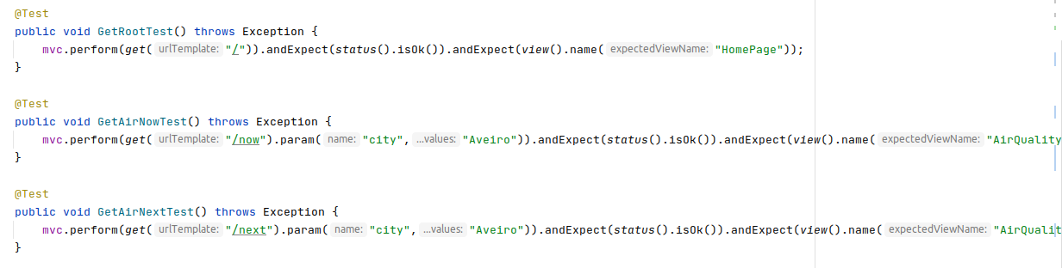

Fig. 5 – Controller test example

The interface was tested using selenium.

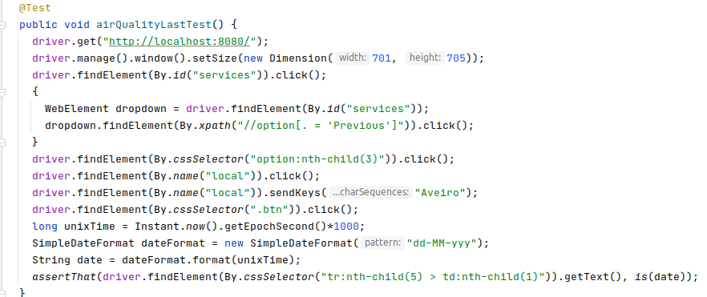

Fig. 6 – Selenium test example

Functional testing
For the functional tests I tested the three data endpoints the user can access throw the interface, the /now, /next and /last using selenium firefox extension.
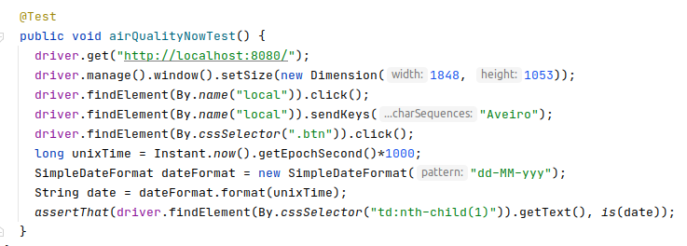

Fig. 7 – Functional test example

Static code analysis
To the static code analysis I used sonar as we learn about it in the TQS classes.
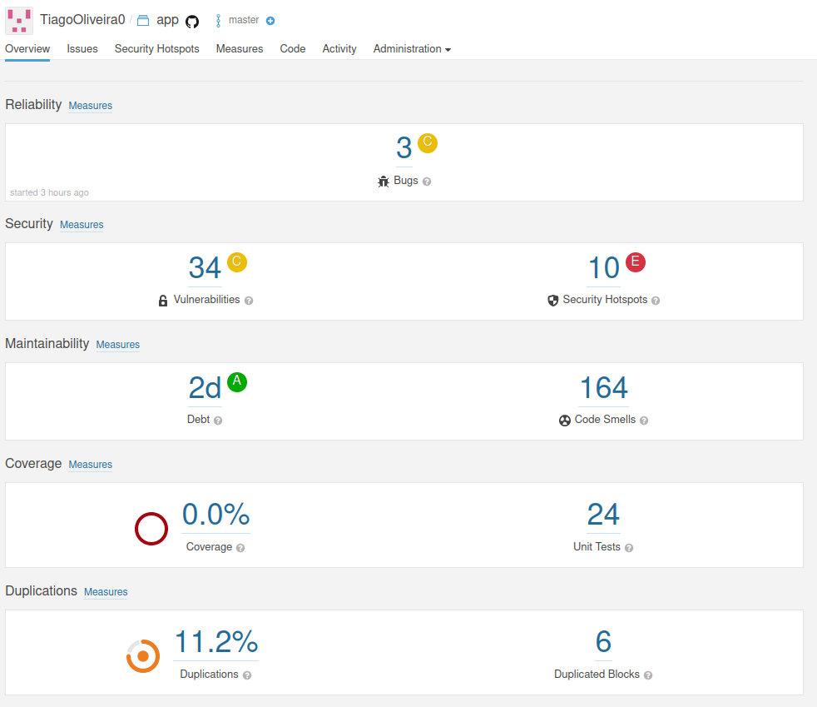

Fig. 8 – Sonar analysis

This was an analysis made by sonar, the average time to solve it all is 2 days as shown, and there are a lot of things to solve such as 164 code smells (most of them are repeated). This is not the final analysis of sonar by the end of the delivery of this project it will look a lot better.

Sonar helped me with the bad practices I was doing along the project, I found out about things I did not knew they were vulnerabilities like printing the error when I get an exception.
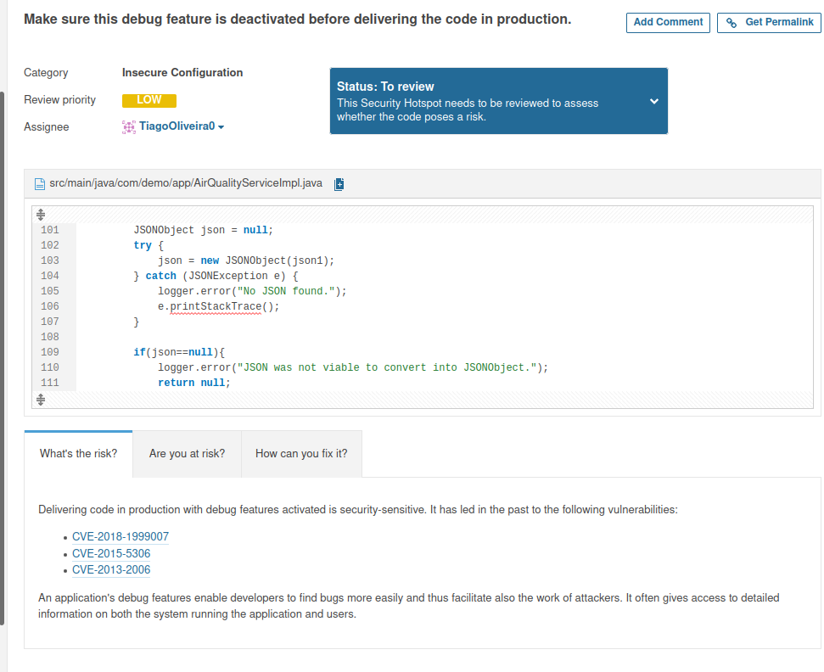

Fig. 9 – Vulnerability detected by sonar analysis

Another code smell I did not know it was a code smell was the following:

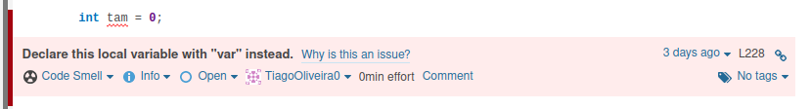

Fig. 10 – Code smell detected with sonar analysis

The final analysis of sonar was a very good improvement since the first one, I could get a total of 0 code smells, 0 vulnerabilities and 0 security hotspots.
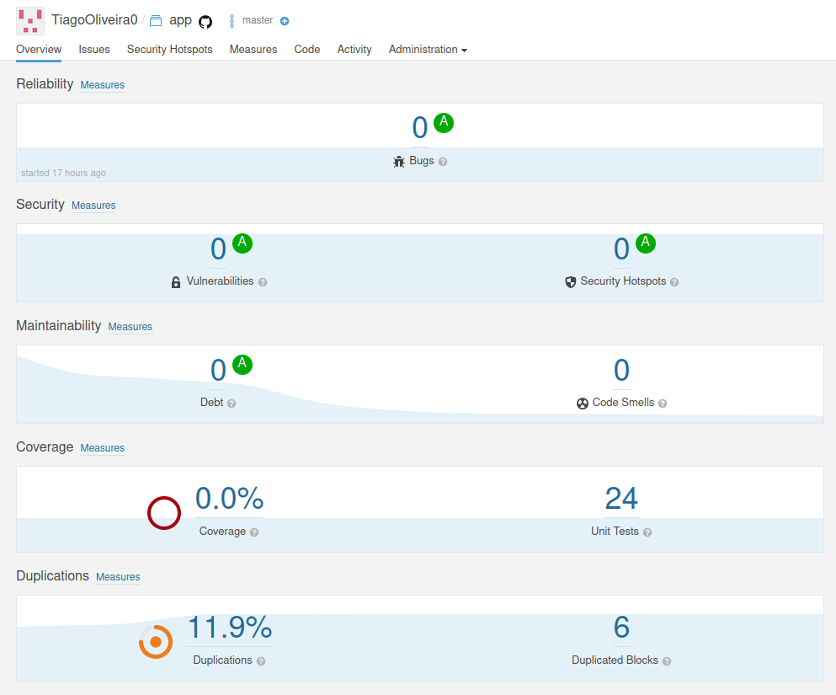

Fig. 11 – Final sonar analysis

Continuous integration pipeline
I implemented a CI pipeline in this project because it helped me having feedback if every commit I was doing was having impact on the tests implementation.
Implementing this pipeline was easy, I just had to do a .yml file and integrate it with github actions. In this yml file I also put sonar so every time I was doing a commit to the repository I had feedback about sonar analysis and test implementation passing or not.

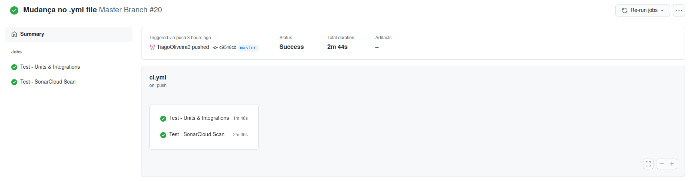

Fig. 12 – Feedback example of the CI pipeline in github actions

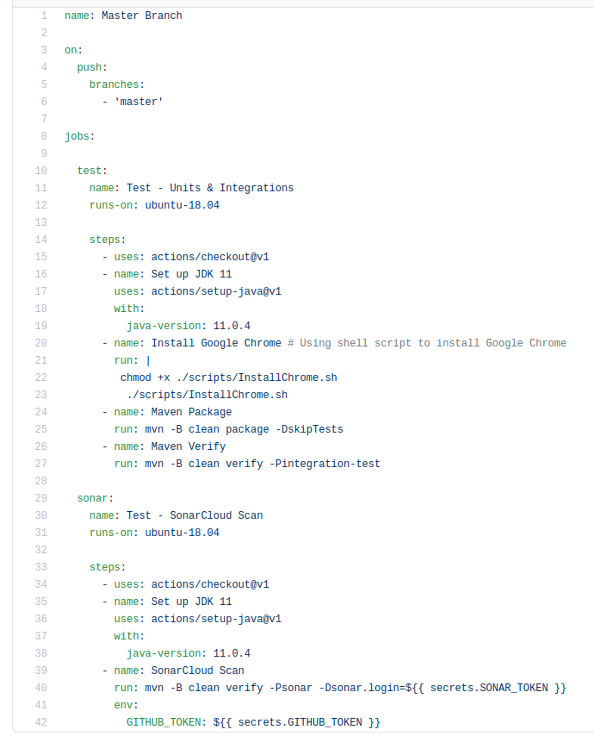

Fig. 13 – yml file with the CI pipeline implementation

References & resources
Project resources

- Project repository: https://github.com/TiagoOliveira0/TQS_PROJ1
- Video demo in the project repository: https://github.com/TiagoOliveira0/TQS_PROJ1/tree/master/project%20demo
- QA dashboard: https://sonarcloud.io/dashboard?id=TiagoOliveira0_TQS_PROJ1

Reference materials

- https://opencagedata.com/
- https://openweathermap.org/api

